Welcome to Ms. Boquet’s Geometry Class
tboquet@cartersvilleschools.org 770-382-3200 ext. 5536
TI-36X Pro OR TI-30XS MultiView
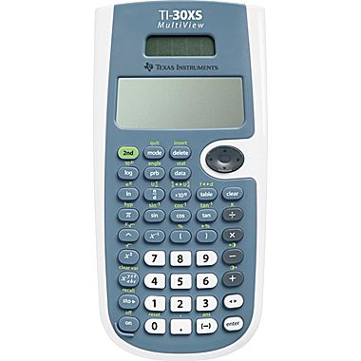
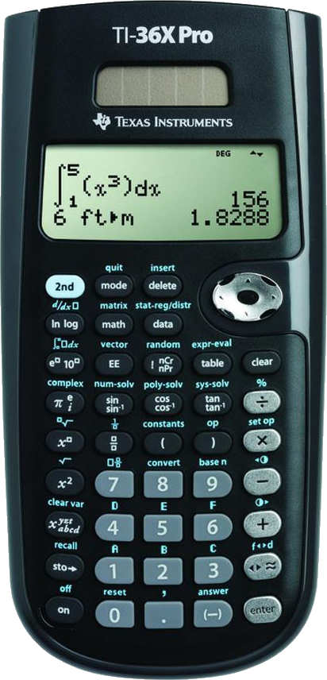
Each student will need to have their own calculator for assignments both
in and out of class. Either of these shown here would be excellent choices.

Being prepared for class every day is a crucial requirement to be successful in class!

2-inch 3-ring Notebook/binder Composition book (old time used to be black and white only)
Notebook Paper Pencil Pouch for 3-ring binder
Pencils, regular and colored Graph Paper
Scissors glue

